**//Q1.**

#include <stdio.h>

int getPower(int x, int n) // function to get x to the power r

{

int pow = 1, i;

for(i=1; i<=n ; i++){

pow = pow * x;

}

return pow;

}

int main(){

int x, r , res;

printf("Enter the base and the power: ");

scanf("%d%d", &x, &r);

res = getPower(x,r);

printf("The desired value of %d to the power %d is %d", x,r,res);

return 0;

}

**Output:**

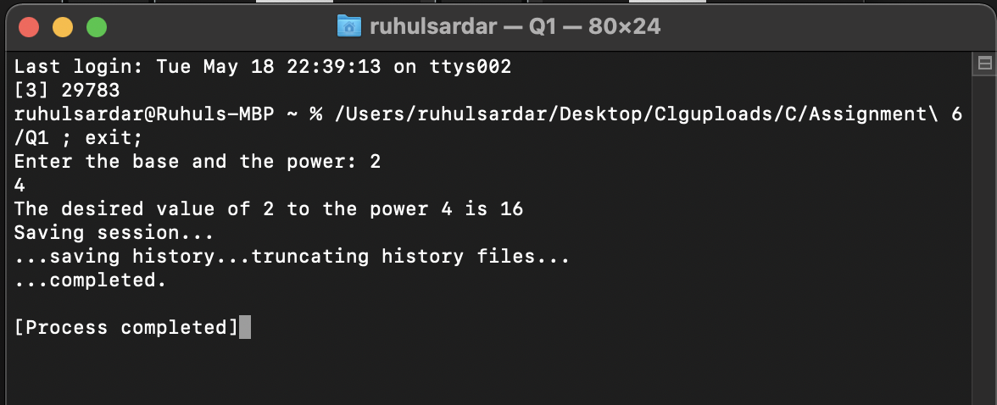



**//Q2.**

#include <stdio.h>

#include <math.h>

long decimalToBinary(int decimalnum)//function to get the binary Equivalent of the decimal number.

{

long binarynum = 0;

int rem, temp = 1;

while (decimalnum!=0)

{

rem = decimalnum%2;

decimalnum = decimalnum / 2;

binarynum = binarynum + rem*temp;

temp = temp * 10;

}

return binarynum;

}

int main()

{

int decimalnum;

printf("Enter a Decimal Number: ");

scanf("%d", &decimalnum);

printf("Equivalent Binary Number is: %ld", decimalToBinary(decimalnum));

return 0;

}

**Output:**

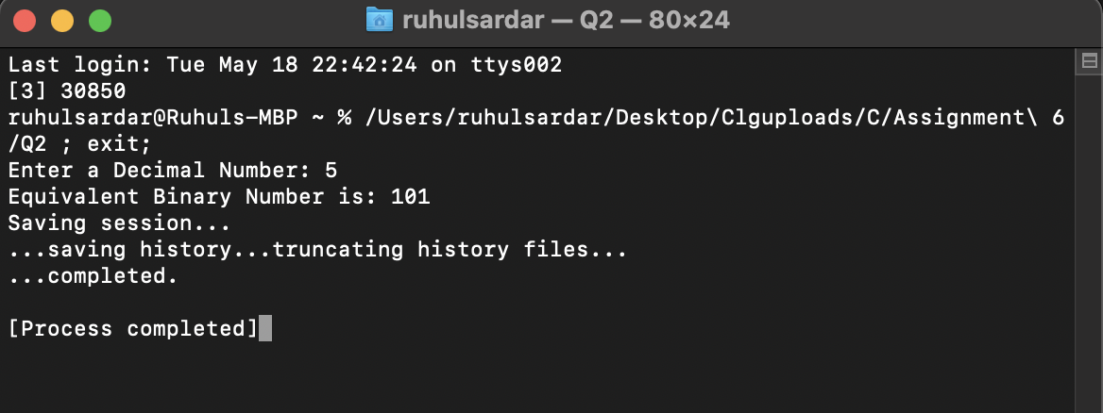



**//Q3.**

#include <stdio.h>

int gcd(int x, int y);

int main()

{

int Num1, Num2;

printf("Please Enter two integer Values \n");

scanf("%d %d", &Num1, &Num2);

printf("GCD of %d and %d is = %d", Num1, Num2, gcd(Num1, Num2));

return 0;

}

int gcd(int x, int y)//function to calculate the gcd of 2 numbers.

{

if (x == 0) {

return y;

}

while (y != 0) {

if (x > y) {

x = x - y;

}

else {

y = y - x;

}

}

return x;

}

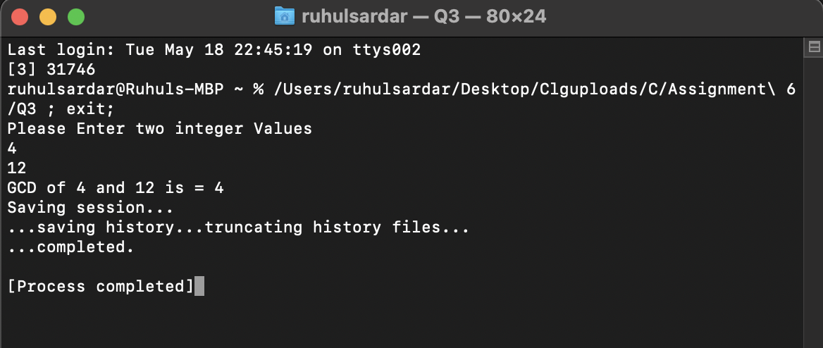**Output:**

**//Q4.** 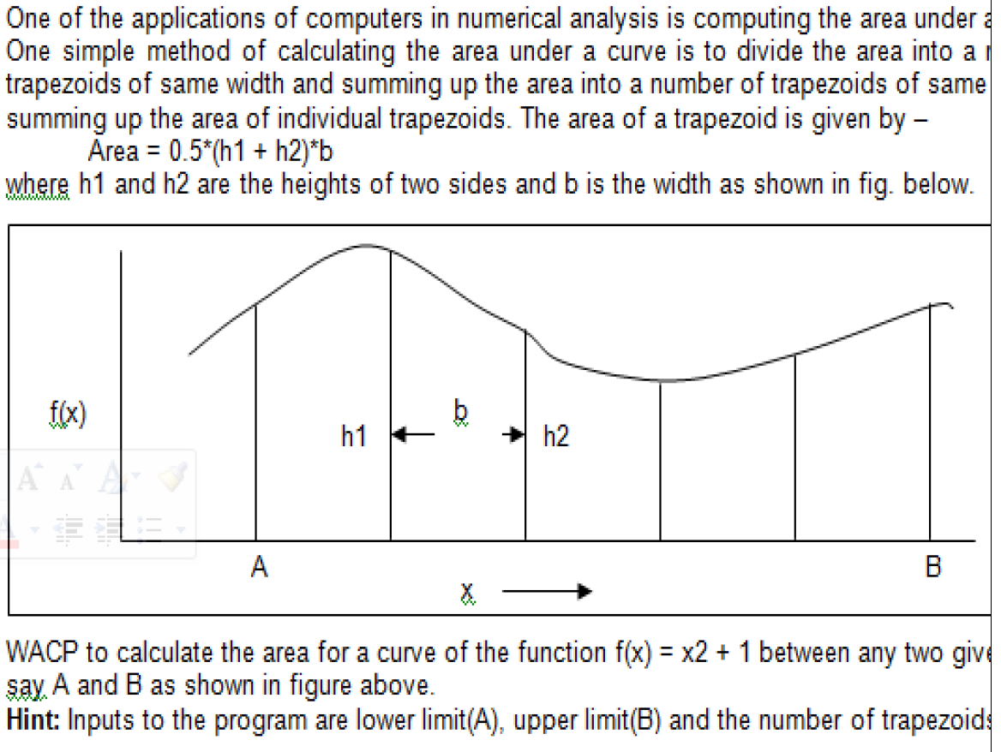

#include<stdio.h>

#include<math.h>

float f(float x)//function get the f(x) = x^2 + 1.

{

return(1+pow(x,2));

}

int main()

{

int i,n;

float x0,xn,h,y[20],so,se,ans,x[20];

printf("\n Enter values of x0,xn,h:\n");

scanf("%f%f%f",&x0,&xn,&h);

n=(xn-x0)/h;

if(n%2==1)

{

n=n+1;

}

h=(xn-x0)/n;

printf("\nrefined value of n and h are:%d %f\n",n,h);

printf("\n Y values \n");

for(i=0; i<=n; i++)

{

x[i]=x0+i*h;

y[i]=f(x[i]);

printf("\n%f\n",y[i]);

}

so=0;

se=0;

for(i=1; i<n; i++)

{

if(i%2==1)

{

so=so+y[i];

}

else

{

se=se+y[i];

}

}

ans=h/3*(y[0]+y[n]+4*so+2*se);

printf("\nfinal integration is %f",ans);

return 0;

}

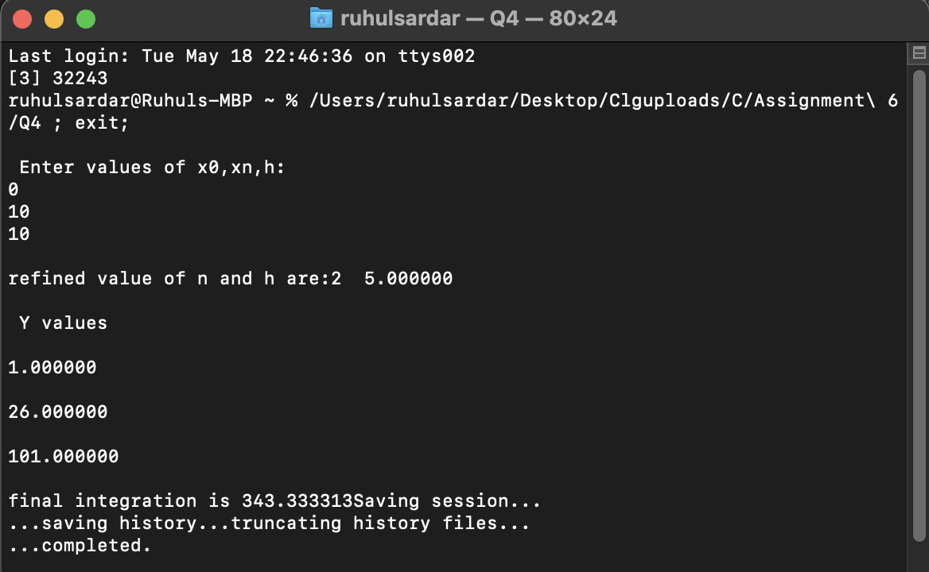**Output:**

**//Q5.**

#include <stdio.h>

#include <math.h>

#include<stdbool.h>

bool checkPronic(int x)// function to check wheather the given number is pronic or not.

{

for (int i = 0;

i <= (int)(sqrt(x));

i++)

if (x == i * (i + 1))

return true;

return false;

}

int main()

{

int n, res;

printf("Enter any number: ");

scanf("%d", &n);

res = checkPronic(n);

if(res == 1)

printf("%d is a pronic number", n);

else

printf("%d is not a pronic number", n);

return 0;

}

**Output:**

